Magnetic Monopole Survey Instructions

May, 2014

RAPID Consortium

Table of Contents

Introduction 2

Configuring 2G SQUID Boxes 2

Tuning I Bias 2

Fig. 1 – I BIAS Turning Dial + Lock + Indicator Bar 2

Adjusting Analog Flux level to zero 2

Fig. 2 – Adjust Analog Flux Offset 3

Reset non-zero Flux-counts 3

Fig. 3 – Reset Flux Counts to Zero 3

Start Time-Series Measurements in the Paleomag Program 4

Opening VRM Data Collection Window 4

Fig. 4 – Opening the VRM Data Collection Window 4

Setup VRM Time-Series 4

File Path Convention to Use 5

Fig. 5 – VRM Data Collection Window 5

Fig. 6 - Running VRM Test – Window 6

# Introduction

Version 2.3.7 of the RAPID Paleomag software and upwards can be used to make a time-series of measurements from your 2G SQUID boxes and save those time VS measurement points to a CSV text file. This time-series tool is simple to use and can be used to do a coordinated Magnetic Monopole Survey across the many RAPID paleomagnetic laboratories distributed globally.

The setup process for the time-series measurements has two parts:

1. Configuring and resetting your 2G SQUID boxes
2. Starting the time-series within the Paleomag software

# Configuring 2G SQUID Boxes

## Tuning I Bias

1. Change the SQUID box from Run Mode to Setup Mode
2. Unlock the I BIAS turn-dial
3. Turn the I BIAS turn-dial back-and forth to find the dial position where the number of red bars in the bar-indicator are at their maximum level.
4. Lock the I BIAS turn-dial
5. Change the SQUID Box from Setup Mode back to Run Mode

### Fig. 1 – I BIAS Turning Dial + Lock + Indicator Bar

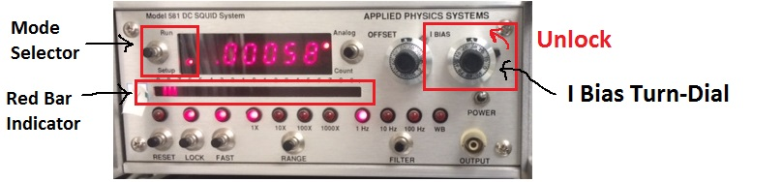

## Adjusting Analog Flux level to zero

1. In Run Mode, set the SQUID Flux level display to Analog Mode.
2. In Run Mode, twist the OFFSET turn-dial until the digital value shown in the SQUID flux level display is as close to zero as you can go (zero plus or minus 0.00010 or so).

### Fig. 2 – Adjust Analog Flux Offset

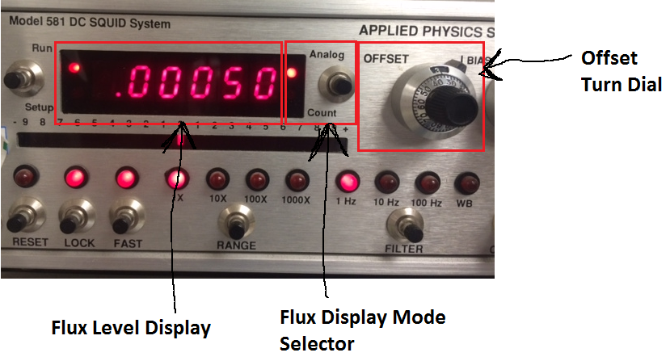

## Reset non-zero Flux-counts

1. In Run Mode, set the SQUID Flux level display to Count Mode.
2. Press the “Reset” push-button and verify that the number of Counts displayed equals zero.
3. Change the SQUID flux level display back to Analog Mode.

### Fig. 3 – Reset Flux Counts to Zero

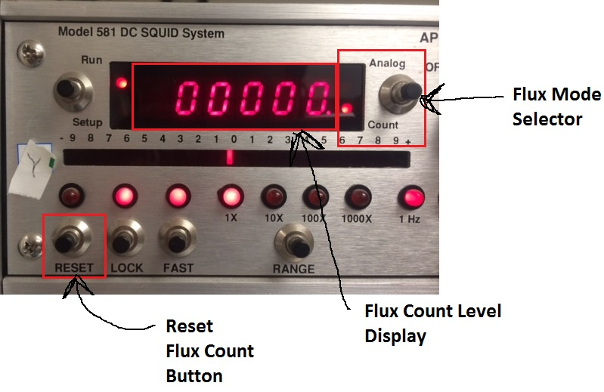

# Start Time-Series Measurements in the Paleomag Program

Open the normal version of the Paleomag program that you use on your computer. Any compiled or uncompiled version of the code written during or after version 2.3.7 (2008) will have the needed VRM Data Collection tool to doing a SQUID measurement time-series.

Once you’ve started the Paleomag program, login. The normal initialization process will run for your system (usually consisting of a home-to-top for the quartz glass tube and possibly also an IRM discharge).

## Opening VRM Data Collection Window

Then, open the Diagnostics->VRM Data Collection window. (See Figure Below)

### Fig. 4 – Opening the VRM Data Collection Window

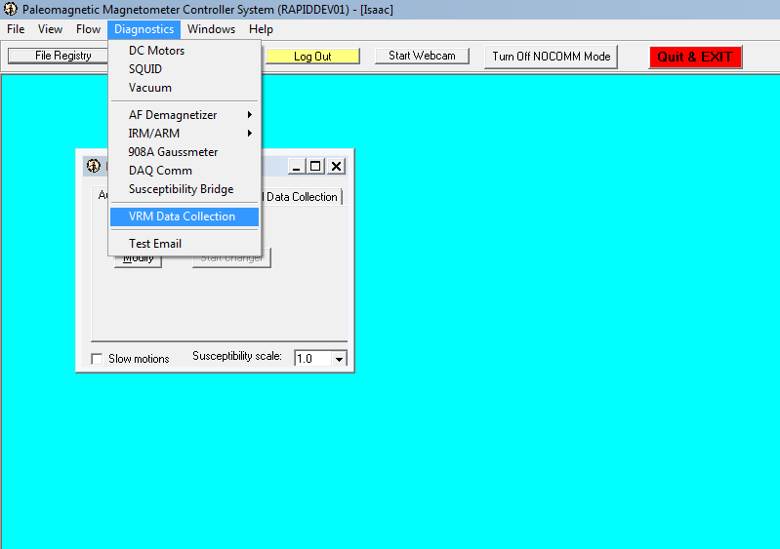

## Setup VRM Time-Series

Once the VRM Data Collection (a.k.a. VRM Decay Test window) has opened, make the following selections:

Measure Every 10 seconds.

Select “Linear” from the drop-down list for the spacing between each measurement.

In the write to file: field, enter in the file path for the file to which you wish to save the SQUID data Time-series. I STRONGLY suggest saving the file directly to your C:\ drive. It makes it easy to locate the file once you end the Time-Series measurements.

### File Path Convention to Use

C:\[The name of your University of Institution]_[The name of your magnetometer]_SQUIDs_[today’s date and time expressed in the format YYYYMMDD_HHMM, with the hours in 24-hour format].csv

For example, for the Lowenstam system at Caltech, on May 20, 2014 at 9:14 am, the file path would be:

C:\Caltech_Lowenstam_SQUIDs_20140520_0914.csv

For example, the Hargraves system at Berkeley, on May 21, 2014 at 3:45 pm, the file path would be:

C:\Berkeley_Hargraves_SQUIDS_20140521_1545.csv

If you have questions about what file-path to use for your system, please send the questions via email to:

[ihilburn@caltech.edu](mailto:ihilburn@caltech.edu) and cc [kirschvink@caltech.edu](mailto:kirschvink@caltech.edu)

### Fig. 5 – VRM Data Collection Window

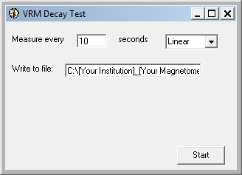

Finally, click the Start button to start the Time-Series measurements. Within ~10 seconds, the first measurement should be displayed in the VRM Decay Test window. When you want to end the Time-Series, click the Stop Button

### Fig. 6 - Running VRM Test – Window

